OPERATOR’S MANUAL

GECKO Battery
WELDING CARRIAGE

1. GENERAL INFORMATION 3
1.1. Application 3
1.2. Technical data 3
1.3. Design 5
1.4. Equipment included 6
2. SAFETY PRECAUTIONS 7
3. STARTUP AND OPERATION 9
3.1. Preparing 9
3.2. Connecting to welding circuits 10
3.3. Positioning at the worksite 11
3.4. Operating 12
3.5. Changing the unit of speed 13
3.6. Troubleshooting 14
4. MAINTENANCE 15
5. ACCESSORIES 16
5.1. 16–22 mm torch clamp 16
5.2. 16–22 mm torch clip 16
5.3. 22–35 mm torch clamp 16
5.4. Short rod 17
5.5. Long rod 17
5.6. Short rod torch holder with clamp 17
5.7. Short rod torch holder with clip 18
5.8. Short rod low torch holder with clip 18
5.9. Long rod torch holder with clamp 18
5.10. Long rod torch holder with clip 19
5.11. Torch extension arm 19
5.12. Edge following guide arms 20
5.13. Adjustable guide arms 21
5.14. Magnet guide arms 22
5.15. Low guide arms 23
5.16. High guide arms 24
5.17. Dual torch mount 25
5.18. Auxiliary magnet blocks 26
5.19. Guiding set 27
5.20. Guide adjustment tool 29
5.21. 76 mm cross slide 30
5.22. Battery charger 31
5.23. Power supply 31
5.24. Power cord 31
5.25. Cable anchor 32
6. WIRING DIAGRAM 33
7. DECLARATION OF CONFORMITY 34
8. QUALITY CERTIFICATE 35
9. WARRANTY CARD 36

GENERAL INFORMATION

Application
The GECKO Battery is a battery-powered welding carriage designed to produce continuous butt and fillet welds using MIG/MAG torches with the handle diameter of 16–22 mm (0.63–0.87’’). The carriage is fixed by permanent magnets and can work in the following welding positions: PA/1F/1G, PB/2F, PC/2G, PD/4F, and PE/4G.
Accessories allow, for instance, using torches with the handle diameter larger than 22 mm, two torches simultaneously, guiding the carriage along outside edges, lap joints and templates, walls low or with holes, and on ceilings, pipes, and tanks. The carriage can also be plugged directly into a 110–240 V power source using an optional power supply.

Technical data
Voltage | 18 V DC, 5.2 Ah
Power | 20 W
Welding position (according to EN ISO 6947 and AWS/ASME) | PA / 1F / 1G  PB / 2F  PC / 2G  PD / 4F  PE / 4G
Minimum path curvature radius | 1000 mm (3.5 ft)
Torch type | MIG/MAG
Torch diameter | 16–22 mm (0.63–0.87’’)
Maximum torch reach | 70 mm (2.76’’)
Maximum permitted cable weight  for horizontal work | 8 kg (18 lbs)
Minimum workpiece thickness | 4 mm (0.16’’)
Ground clearance | 4 mm (0.16’’)
Horizontal pulling force | 150 N
Cross slide adjustment range | 0–35 mm (0–1.38’’, up-down, left-right)
Guide arm adjustment range | 0–100 mm (0–3.93’’)
Horizontal speed* | 0–110 cm/min (0–43.3 in/min)
Weight | 8.6 kg (19 lbs)
* With battery fully charged.

320 mm (12.6’’)
277 mm (10.9’’)
360 mm (14.2’’)

Design
The GECKO Battery welding carriage consists of a chassis, a drive system, a controller, a cross slide, two guide arms, a battery, and a torch holder. The drive system contains a gear-motor that drives four rubber wheels.
Permanent magnets fitted at the carriage bottom ensure proper clamping to ferromagnetic surfaces. The cross slide allows for precise control of the torch holder position in both the horizontal and vertical axis, and connecting the arc ignition cable will enable the carriage to ignite an arc when selecting a travel direction.
Arc ignition socket
Safety line lug
Cross slide
Torch holder
Guide arm
Power switch
Magnet ON/OFF lever
Control panel
Battery

- View of the GECKO Battery

LED display
Travel direction switch (Left / O / Right)
Arc ignition switch (TEST / O / I)
Speed adjustment knob

- View of the control panel

Equipment included
The GECKO Battery is supplied including the following elements.
Carriage | 1 unit
Foam filled cardboard box | 1 unit
5.2 Ah battery | 1 unit
Long rod torch holder with clamp | 1 unit
6.5 m (21 ft) arc ignition cable | 1 unit
4 mm hex wrench | 1 unit
Operator’s Manual | 1 unit

SAFETY PRECAUTIONS
- Before beginning, read this Operator’s Manual and complete proper occupational safety and health training.
- Use the carriage only in applications specified in this Operator’s Manual.
- The carriage must be complete and all parts must be genuine and fully operational.
- The specifications of the power source must conform to those specified on the rating plate.
- When a power supply is used, plug it into a properly grounded power source.
- Never carry the carriage by the cords or the arc ignition cable and never pull them as this may damage them and result in electric shock.
- Untrained bystanders must not be present near the carriage.
- Before beginning, make sure that the correct is the condition of the carriage and battery, power supply and power source, cords, arc ignition cable, plugs, control panel, and wheels.
- Keep the carriage dry. Exposure to rain, snow, or frost is prohibited.
- Keep the work area well lit, clean, and free of obstacles.
- Never use near flammable liquids or gases, or in explosive environments.
- Make sure that the rubber of the wheels is clean and not damaged.
- Never disassemble the cover of the wheels.
- Remove objects attracted to the chassis by the magnet.
- Transport and position the carriage using the carrying handle and only when the magnet ON/OFF lever is set to the position ‘O’.
- Position the carriage on the ferromagnetic workpiece in such a way that the wheels are in contact with the surface and there is no contact between the surface and the chassis.
- Do not stay below the carriage placed at heights.
- Plug the cords and the arc ignition cable only when the power switch is set to the position ‘O’.
- Keep the sockets clean. Do not use compressed air for cleaning.
- Install only MIG/MAG torches with the handle diameter corresponding to the torch holder in use.
- Position the torch not more than 70 mm (2.76’’) outward from the left or right side of the carriage.
- Keep the torch cables from coming in contact with the surface. They must be suspended to reduce the load of the carriage. Use only cables whose weight is not more than 8 kg (18 lbs) for horizontal work.
- Operating on curvatures with a convex or concave radius less than 1000 mm (3.5 ft) is prohibited.
- When operating at heights, use a safety line to protect the carriage from dropping.
- Always use eye protection (helmet, shield, and screen), hearing protection, gloves, and protective clothing during operation. Do not wear loose clothing.
- Before every use, inspect the carriage to ensure it is not damaged. Check whether any part is cracked or improperly fitted. Make sure to maintain proper conditions that may affect the operation of the carriage.
- Never try to manually stop the motion of the carriage. To stop, set the travel direction switch to the position ‘O’.
- Maintain only when the battery / power supply is removed.
- Repair only in a service center appointed by the seller.
- If the carriage falls from any height, is wet, or has any other damage that could affect the technical state of the carriage, stop the operation and immediately send the carriage to the service center for inspection and repair.
- Never leave the carriage unattended during operation.
- Remove from the worksite and store in a secure and dry location when not in use.

STARTUP AND OPERATION

Preparing
Use the carrying handle to transport the carriage to the worksite. Then, set to the position ‘O’ all the switches (power, travel direction, and arc ignition switch) and the magnet lever. Next, insert the torch into the torch holder and secure with the knob.
Precise torch position adjustment knobs
Levers securing
the torch position and angle
Knob securing the torch in the holder
Screw securing the guide arm
Carrying handle
- View from the back side

Connecting to welding circuits
The carriage can control two torches using the arc ignition cable plugged into the arc ignition socket. To do this, connect any blue-jacketed wire to any terminal of the welding circuit, and then connect the second blue-jacketed wire to the second terminal of the same circuit, according to the diagram shown in Fig. 4. To control the second torch, connect the green-jacketed wires to the terminals of the second welding circuit.
blue

blue

green

green

Welding circuit 1
Welding circuit 2

- Connecting the arc ignition cable to welding circuits
To check whether the arc ignition cable is connected correctly, power the carriage by setting the power switch to the position ‘I’, and set the arc ignition switch to the position TEST, which should enable the arc for a while.

Positioning at the worksite
The guide arms must be positioned so that the carriage is in constant contact with the workpiece. They can be set by a constant step (interval adjustment), or continuously after they are swapped (continuous adjustment). To set them properly when the carriage travels to the left, use the 4 mm hex wrench to loosen the screw securing the right guide arm, move out the right arm about 10 mm (0.4’’) or one groove more than the left arm (Fig. 5), and then retighten the screw.
Travel direction
Continuous adjustment
Interval adjustment
Swap the guide arms to change between methods of adjustment
Groove
Moving out the right arm by one groove

- Proper positioning of the guide arms
Switch the magnet ON/OFF lever from left (‘O’) to right (‘I’), which will change the clamping force from minimum to maximum. Loosen the levers to adjust the position and angle of the torch, and set the torch position precisely using two knobs located at the cross slide. When operating at heights, attach a safety line to the lug to prevent possible injury if the carriage loses the clamping. The safety line is not included in standard equipment.

Operating
After setting the power switch to the position ‘I’ the carriage will turn on, which will illuminate all segments of the display (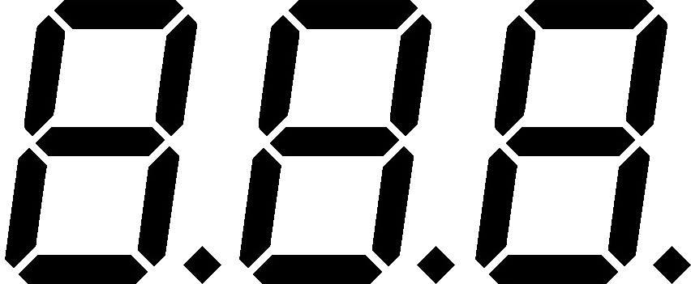). After a while, the indication will change to 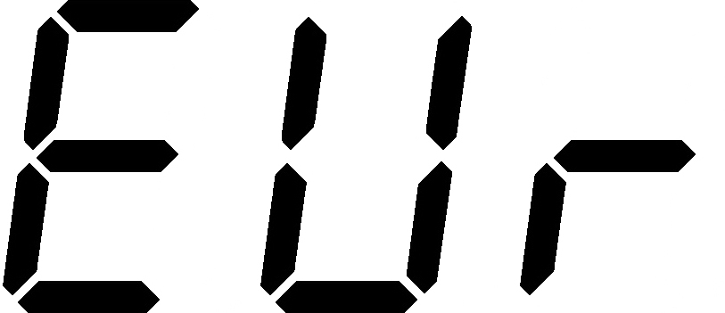 if the unit of speed is set to centimeters per minute, or to 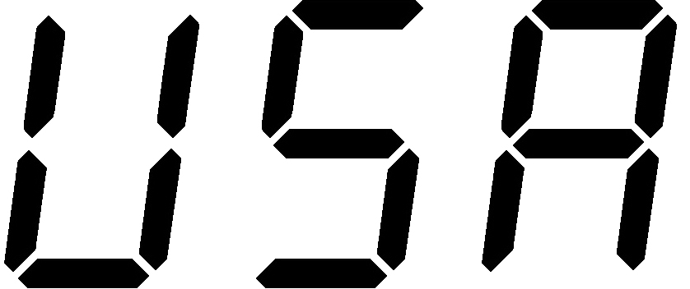 for inches per minute. Then, the carriage speed will show. The speed can be adjusted by rotating the knob located on the panel. If the carriage is to control the torch, set the arc ignition switch to the position ‘I’.

CAUTION! If the arc ignition switch is set to position ‘I’, the torch will start welding immediately after selecting a travel direction.

Use the travel direction switch to select a direction of motion, which will start the movement of the carriage with the speed shown on the display. The speed value flashing indicates the battery is partly discharged. After the battery is discharged fully, the drive will stop.
To stop the motion, set the travel direction switch to the position ‘O’. After the work is finished, turn off the carriage using the power switch.

Changing the unit of speed
To change the unit of speed from centimeters per minute to inches per minute, or vice versa, remove the battery or the power supply, and follow the steps shown in Fig. 6.
Use the 2.5 mm hex wrench to loosen the fixing screws to access the back side of the control panel.
Place the jumper cap in the position corresponding to the required unit.
cm
inch

- Changing the unit of speed
After changing the unit and powering the carriage again, the actual measurement unit will show. When the jumper cap connects the left and center pin, the display shows and the speed is given in centimeters per minute. When the jumper cap connects the center and right pin, the display shows message and the speed is indicated in inches per minute.
The 2.5 mm hex wrench needed to unscrew the control panel is not included in standard equipment.

Troubleshooting
Message | Problem | Solution
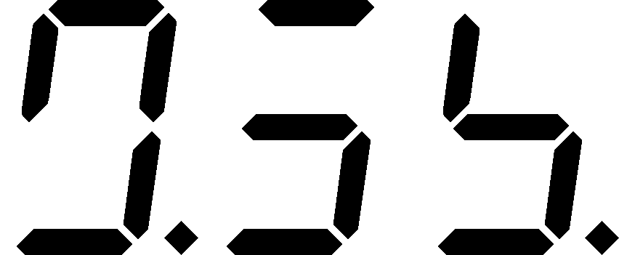 | Not all display segments illuminated after powering indicate a problem with the display or controller. | Contact service center for inspection and repair.
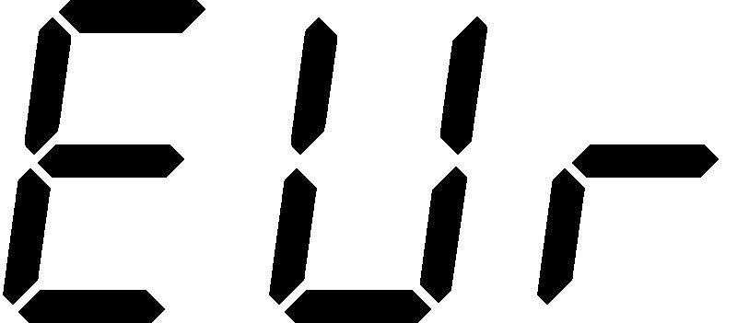 | Speed displayed in centimeters per minute instead of inches per minute. | Follow instructions given in the section “Changing the unit of speed.”
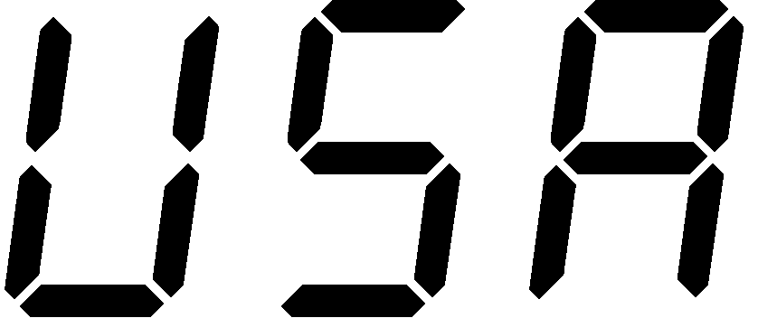 | Speed displayed in inches per minute instead of centimeters per minute. | Follow instructions given in the section “Changing the unit of speed.”
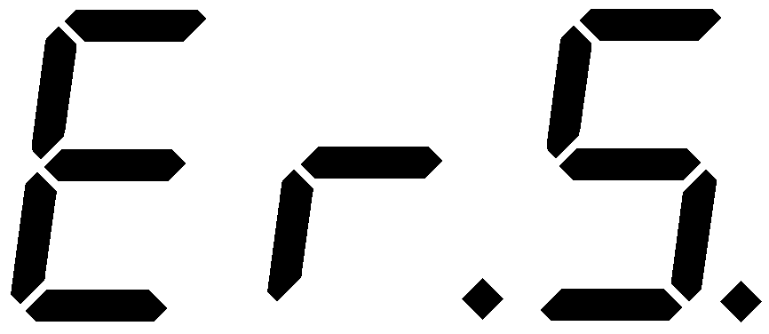 | 1. Travel direction switch not in position ‘O’ when powering.  2. Displayed during motion indicates a malfunction of the travel direction switch or travel direction identification circuit of the controller. | 1. Set the travel direction switch to the position ‘O’. If the message still appears, contact service center for inspection and repair.  2. Contact service center for inspection and repair.
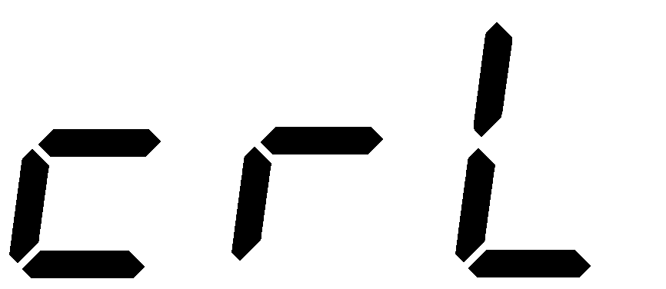 | Motor overload (safe current level exceeded) causing the immediate stop of the carriage. | Use welding cables that do not exceed maximum weight specified in technical data.  Adjust the arrangement of the cables that block the motion of the carriage.  Remove any other elements that block the carriage or its wheels.  If this message still appears, contact service center for inspection and repair.
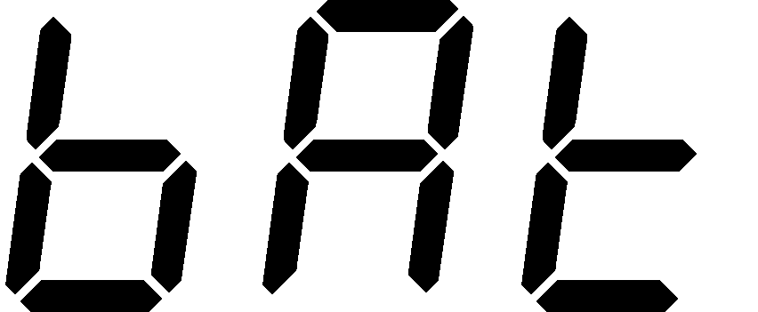 | Battery discharged (voltage dropped below 14 V) causing the immediate stop of the carriage. | Charge the battery or replace to a fully charged.

MAINTENANCE
Daily:
- Clean the chassis and the wheels.
- Clean the rollers of the guide arms and make sure that the rollers rotate freely.
- Clean the torch nozzle. Replace if damaged.
- Inspect the battery. Replace if damaged.
Monthly:
- Check whether the knob and the switches operate as intended. Replace if loose or damaged.
- Inspect cables, cords, and hoses. Replace if damaged.
- Tighten screws if loose.

ACCESSORIES

16–22 mm torch clamp
Allows using a torch with the handle diameter of 16–22 mm (0.63–0.87’’).
Part number:
ZRZ-0466-04-01-00-0

16–22 mm torch clip
Allows using a torch with the handle diameter of 16–22 mm (0.63–0.87’’). Tighten the torch in the clip using the 4 mm hex wrench.
Part number:
ZCS-0476-06-01-00-0

22–35 mm torch clamp
Allows using a torch with the handle diameter of 22–35 mm (0.87–1.38’’).
Part number:
ZRZ-0466-19-00-00-0

Short rod
Provides a 120 mm (4.72’’) reach.
Part number:
WLK-0476-20-01-00-0

Long rod
Provides a 240 mm (9.45’’) reach.
Part number:
WLK-0466-04-10-00-0

Short rod torch holder with clamp
Allows using a torch with the handle diameter of 16–22 mm (0.63–0.87’’).
Part number:
UCW-0476-20-00-00-0

Short rod torch holder with clip
Allows using a torch with the handle diameter of 16–22 mm (0.63–0.87’’). Tighten the torch in the clip using the 4 mm hex wrench.
Part number:
UCW-0476-27-00-00-0

Short rod low torch holder with clip
Allows using a torch with the handle diameter of 16–22 mm (0.63–0.87’’). Tighten the torch in the clip using the 4 mm hex wrench.
Part number:
UCW-0476-06-00-00-0

Long rod torch holder with clamp
Allows using a torch with the handle diameter of 16–22 mm (0.63–0.87’’).
Part number:
UCW-0466-04-00-00-0

Long rod torch holder with clip
Allows using a torch with the handle diameter of 16–22 mm (0.63–0.87’’). Tighten the torch in the clip using the 4 mm hex wrench.
Part number:
UCW-0466-22-00-00-0

Torch extension arm
Extends the reach of the torch. To install the arm, unscrew the M5x10 screws fixing the cross slide using the 4 mm hex wrench and use the same screws to fix the cross slide at the end of the arm as shown in the figure. Fix the arm to the carriage using M5x16 screws.
M5x16
M5x10
Part number:
PRD-0466-43-00-00-0

Edge following guide arms
Allow guiding the carriage along outside edges. Install the guide arms after unscrewing the standard guide arms using the 4 mm hex wrench.
Part number (2 units):
PRW-0466-41-00-00-1

Adjustable guide arms
Allow guiding the carriage along lap joints and templates. Install the guide arms after unscrewing the standard guide arms using the 4 mm hex wrench.
Part number (2 units):
PRW-0466-42-00-00-1

Magnet guide arms
Allow guiding the carriage on ceilings. Install the guide arms after unscrewing the standard guide arms using the 4 mm hex wrench.
Part number (2 units):
PRW-0466-52-00-00-1

Low guide arms
Allow guiding the carriage along low walls. Install the guide arms after unscrewing the standard guide arms using the 4 mm hex wrench.
Part number (2 units):
PRW-0466-65-00-00-1

High guide arms
Allow guiding the carriage along walls with holes. Install the guide arms after unscrewing the standard guide arms using the 4 mm hex wrench.
Part number (2 units):
PRW-0466-66-00-00-1

Dual torch mount
Allows using a second torch. Use the 5 mm hex wrench to remove four side screws, and then fix the mount to the carriage with four M6x20 screws and washers.
Part number:
PDT-0466-40-00-00-0

Auxiliary magnet blocks
Increase the clamping force of the carriage. Use the 4 mm and 5 mm hex wrenches to unscrew eight side screws, including four screws and washers fixing the cross slide bracket, and then install the blocks. Use a spacer plate with the right magnet block.
Part number:
BLO-0466-44-01-00-0
Part number:
BLO-0466-45-01-00-0 (spacer plate included)

Guiding set
Allows guiding the carriage on planes along a straight line, and on pipes and tanks. A single flexible rail is 1.85 m (6 ft) long. The holding force of a magnet block placed on a 5 mm (0.2’’) thick ferromagnetic surface is 90 N up to a temperature of 100°C (212°F). At 180°C (356°F) the force decreases to 54 N.
Connect two rails with the M5x16 screws using the 3 mm hex wrench to form a butt or lap joint. Install the guide arms after unscrewing the standard guide arms using the 4 mm hex wrench.
Flexible rail (1 unit):
PRW-0466-50-01-01-0
Magnet block set:
BLO-0466-68-00-00-0
(includes: 10 magnet blocks and 22 screws M5x16)
Butt joint
Lap joint
Guide arms (2 units):
PRW-0466-50-02-00-1

Guide adjustment tool
Allows the guide to be positioned parallel to an outside edge or a groove.
Part number:
UST-0466-53-00-00-0
Fix the magnets to the guide, and position the guide on the workpiece along the direction of welding. Loosen the levers and put the tool onto the first magnet, resting the side of the pilot pin on an outside edge as in the figure below or placing the tip of the pilot pin in a groove. Lock the levers in this position, pull the further part of the guide off the workpiece (1), and begin moving the tool along the guide (2) to clamp the successive magnets to the workpiece.
1
2

76 mm cross slide
Extends either up-down or left-right adjustment range from 0–35 mm (0–1.38’’) to 0–76 mm (0–3’’).
Part number:
ZSP-0466-46-00-00-1

Install in place of the standard cross slide after unscrewing eight screws using the 4 mm hex wrench.

Battery charger
Allows recharging the battery from either 220–240 V or 120 V power source.
Part number:
LDW-000006 (220–240 V, 50/60 Hz)
LDW-000007 (120 V, 60 Hz)

Power supply
Allows connecting the carriage to a 110–240 V power source through a power cord instead using the battery.
Part number:
ZSL-0526-20-00-00-0

Power cord
Allows connecting the power supply to a power source. The length of the power cord is 3 m (10 ft).
Part number:
PWD-0466-18-00-00-0 (230 V CEE)
PWD-0466-21-00-00-0 (230 V AU)
PWD-0466-16-00-00-0 (115 V USA)
PWD-0466-23-00-00-0 (115 V UK)

Cable anchor
Anchors gas cables and power cord to relieve stress for the torch holder.
Part number:
PDT-0526-21-00-00-0

WIRING DIAGRAM
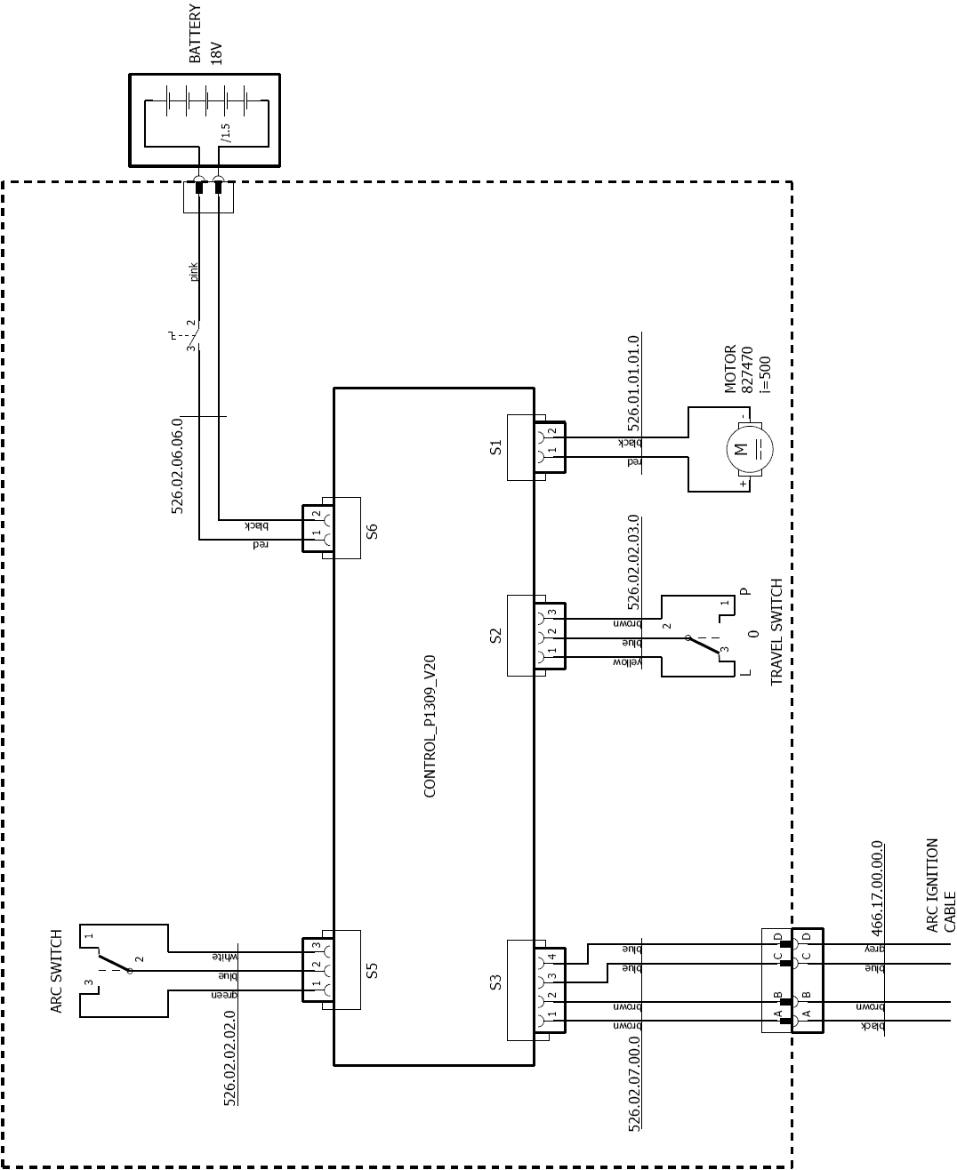

DECLARATION OF CONFORMITY

EC Declaration of Conformity

We

PROMOTECH sp. z o.o.
ul. Elewatorska 23/1
15-620 Białystok
Poland

declare with full responsibility that:

GECKO BATTERY WELDING CARRIAGE

is manufactured in accordance with the following standards:
- EN 60204-1
- EN 60974-10
and satisfies safety regulations of the guidelines: 2004/108/EC, 2006/95/EC, 2006/42/EC.

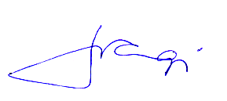
Białystok, 6 May 2014 ___________________________
Marek Siergiej
Chair

QUALITY CERTIFICATE

Machine control card
GECKO BATTERY WELDING CARRIAGE

Serial number .....................................................................

Electric test
Type of test | Result | Name of tester
Test with sinusoidal voltage  (voltage 1000 V, frequency 50 Hz) |  | ...................................  Date
Resistance of the protective circuit | ............ Ω | ...................................  Signature

Quality control .................................................

Adjustments, inspections
Quality control .................................................

WARRANTY CARD

WARRANTY CARD No...........

.......................................................................... in the name of Manufacturer warrants the GECKO Battery Welding Carriage to be free of defects in material and workmanship under normal use for a period of 12 months from the date of sale.
This warranty does not cover wheels as well as damage or wear that arise from misuse, accident, tempering or any other causes not related to defects in workmanship or material.

Date of production

Serial number

Date of sale

Signature of seller

1.07 / 9 February 2016

WE RESERVE THE RIGHT TO MAKE CHANGES IN THIS MANUAL WITHOUT NOTICE

