OPERATOR’S MANUAL

ABM-28
Auto Feed Bevelling Machine
for Plate Edges

1. GENERAL INFORMATION 3
1.1. Application 3
1.2. Technical data 3
1.3. Design 4
1.4. Equipment included 6
2. SAFETY PRECAUTIONS 7
3. STARTUP AND OPERATION 9
3.1. Assembling 9
3.2. Setting the bevel parameters 11
3.3. Operating 12
3.4. Replacing the cutting inserts 14
3.5. Replacing the milling head 15
3.6. Using optional milling unit supports 16
4. ACCESSORIES 18
4.1. Support for bevelling 36–70 mm plates at 0° to 60° 18
4.2. Support for bevelling 36–70 mm plates at 0° to –60° 18
4.3. 1.2 m (47’’) guide track 19
4.4. Support for J-bevelling 20–70 mm plates 19
4.5. Clamp for 36–70 mm plates 20
4.6. Track clamp for 36–70 mm plates 20
4.7. Clad removal attachment 21
4.8. Clamp of clad removal attachment for 36–80 mm and 81–127 mm plates 23
4.9. Track clamp of clad removal attachment for 36–80 mm and 81–127 mm plates 23
5. WIRING DIAGRAM 24
6. SPARE AND WEARING PARTS 25
7. DECLARATION OF CONFORMITY 26
8. QUALITY CERTIFICATE 27
9. WARRANTY CARD 28

Read Operator’s Manual before starting

GENERAL INFORMATION

Application
The ABM-28 is a bevelling machine designed to mill edges of plates with the thickness of up to 35 mm (1.38’’). The bevelling angle can be set in the entire range from 60° to –60°, including facing at 0°. The feed is performed automatically after starting the machine.
Accessories allow bevelling of 36–70 mm (1.38–2.76’’) thick plates at the angle set in the entire range from 0° to 60° (including facing) or from 0° to –60°. It is also possible to establish J-bevels in 20–70 mm (0.79–2.76’’) thick plates and to remove clad of up to 5 mm (0.2’’) depth from plates with a thickness of up to 127 mm (5’’).

Technical data
1211 mm (47.7’’)
619 mm (24.4’’)
532 mm (20.9’’)

Voltage | 1~ 220–240 V, 50–60 Hz
Power | 1600 W
Rotational speed (without load) | 2780 rpm
Protection level | IP 20
Protection class | I
Bevel angle (ß) | 60 to –60° (Fig. 1)
Maximum bevel width (b) | 35 mm (1.38’’, Fig. 1)
Feed speed | 250–500 mm/min (10–20 in/min)
Minimum plate thickness | 10 mm (0.39’’)
Minimum plate width* | 110 mm (4.33’’)
Weight | 78.5 kg (173 lbs)
* The plate and the guide must be well fixed, and the machine must be balanced.

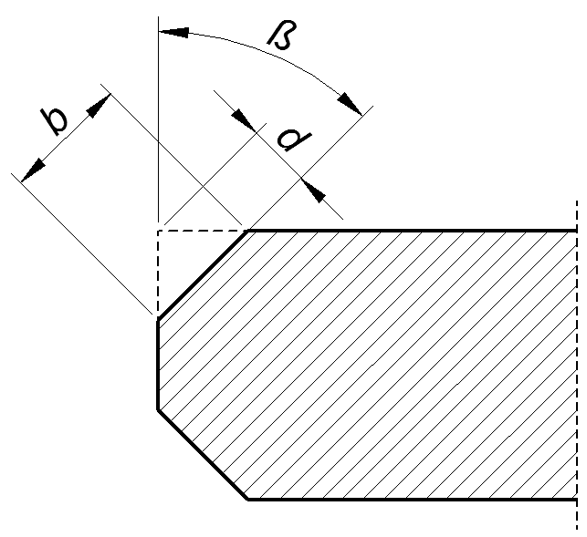
β | 0° | 30° | 45° | 60°
b | 35 mm | 30 mm | 28 mm | 30 mm
- Bevel dimensions; maximum bevel width depending on the angle

Design
The ABM-28 bevelling machine consists of a milling unit, milling unit support, guide, a carriage for moving the milling unit along the guide, two clamps for fixing a plate, and three track clamps for positioning the guide and fixing it to the plate. The detailed design is shown in Fig. 2.

Guide segment
Supply socket for the milling unit
Emergency switch
Travel direction switch
Speed adjusting knob
Power ON/OFF switch
Motor ON switch
Bevel depth adjusting lever
Milling head
Bevel depth lock lever
Bevel depth indicator
Bevel angle lock lever
Protective screw
Protective screw
Bevel angle scale
Adjusting screw
Bevel depth
scale
A
A
Carrying handle
Clamping lever
Clamping rod
Bevel angle lock lever
Chip guard
Spindle lock button
Motor OFF switch
Overload lamp
Chip container
Container handle
Container bracket
Handles

- View of the machine

Equipment included
The ABM-28 is supplied including the following elements.
Carriage installed on a guide track | 1 unit
Wooden box | 1 unit
Additional guide track | 1 unit
Clamp for 10–35 mm (0.39–1.38’’) plates | 2 units
Track clamp for 10–35 mm (0.39–1.38’’) plates | 3 units
Milling unit support for bevelling 10–35 mm (0.39–1.38’’) plates at 60° to –60° | 1 unit
Milling unit (includes milling head with 7 cutting inserts) | 1 unit
Chip container | 1 unit
Tool container | 1 unit
4 mm hex wrench | 1 unit
5 mm hex wrench | 1 unit
6 mm hex wrench | 1 unit
8 mm hex wrench | 1 unit
13/17 mm flat wrench | 1 unit
T15P torx screwdriver | 1 unit
Nut, spring washer, and round washer for installing the milling unit support | 2 sets
Grease for screws | 1 unit
Operator’s Manual | 1 unit

SAFETY PRECAUTIONS
- Before beginning, read this Operator’s Manual and complete proper occupational safety and health training.
- Use the machine only in applications specified in this Operator’s Manual.
- The machine must be complete and all parts must be genuine and fully operational.
- The specifications of the power source must conform to those specified on the rating plate.
- The machine must be plugged into a properly grounded power source.
- Never pull the cords as this may damage them and result in electric shock.
- Untrained bystanders must not be present near the machine.
- Before beginning, ensure the correct condition of the machine, power source, power cord, plug, control components, milling head, and cutting inserts.
- Make sure that protective screws are present at the both ends of the guide.
- Keep the machine dry. Exposure to rain, snow, or frost is prohibited.
- Keep the work area well lit, clean, and free of obstacles.
- Never use machine near flammable liquids or gases, or in explosive environments.
- Use only tools specified in this Operator’s Manual.
- Never use cutting inserts that are dull or damaged.
- Install the cutting inserts and milling head securely. Remove adjusting keys and wrenches from the work area before connecting the cord to the power source.
- If the cutting edge of an insert is worn, rotate the insert in the socket by 90° or, if all the edges are worn, replace with a new insert specified in this Operator’s Manual.
- Before every use, inspect the machine to ensure it is not damaged. Check whether any part is cracked or improperly fitted. Make sure to maintain proper conditions that may affect the operation of the machine.
- Always use safety goggles, hearing protection, protective shoes, and protective clothing during operation. Do not wear loose clothing.
- Do not touch moving parts or chips formed during milling. Prevent objects from being caught in moving parts.
- After every use, remove chips from the machine, especially from the milling head. Do not remove chips with bare hands. Clean the machine with a cotton cloth without using any agents.
- Carry the chip container using the handles.
- Cover steel parts with a thin anti-corrosion coating to protect the machine from rust when not in use for any extended period.
- Maintain the machine and install/remove parts and tools only when the machine is unplugged from the power source.
- Repair only in a service center appointed by the seller.
- If the machine falls from any height, is wet, or has any other damage that could affect the technical state of the machine, stop the operation and immediately send the machine to the service center for inspection and repair.

STARTUP AND OPERATION

Assembling
The carriage set on the guide in the leftmost position must be placed on the plate between two clamps in the manner shown in Fig. 3a. If needed, extend the guide length by connecting additional guide segments, and tighten the set screws using the 4 mm hex wrench (Fig. 3b). Then, install the protective screws 1 and 2 at the both ends of the guide, and position the guide using track clamps in such a way to align the track clamps with respective surfaces of the guide and plate. Fix the track clamps using levers (3, 4, 5), and tighten the clamp screws by rotating the clamping rods (6, 7). To adjust the pressing force of the track clamps depending on the plate thickness, use the adjusting screws 8 which can be located in one of three track clamp holes.
5
3
7
6
a)
4
1
2
11
9
10
8
b)
Set screw
- Placing the machine on the plate (a); installing additional guide segments (b)

If the plate is to be machined at a negative angle (from the bottom), loosen two milling unit support screws using the 4 mm hex wrench and set the indicator to the value of the plate thickness (9). Position the milling unit support on the screws (10), in the shown order place the washers under the nuts (11), and tighten the nuts using the 13 mm flat wrench.
Set the lever 1 in the position as in Fig. 4, insert the milling unit horizontally into the support (2), and lock the bevel depth lock lever (3). If the plate is to be machined at a positive angle (from the top), set the chip container on the brackets (4).
2
3
4
1
- Installing the milling unit

Setting the bevel parameters
Loosen the lever 1 (Fig. 5), rotate the lever 2 to set a proper milling head penetration in the workpiece indicated on the scale 3 (one graduation equals 1 mm, 0.04’’), and then lock the position using the lever 1.
1
3
2
6
5
4
- View of the milling unit
Next, loosen the levers 4 and 5, rotate the milling unit in such a way to set a proper bevel angle on the scale 6, and then lock the levers 4 and 5.
Start bevelling with the milling head retracted as far as possible, especially when milling at the angle of 0°.
Proceed with caution if the milling unit is inclined at a high negative angle. In such a case when readjusting the milling head penetration near the maximal retraction, hold the handles tightly not to allow the milling unit to slip down from the support after the bevel depth lock lever 1 is unlocked.

Operating
Plug the milling unit power cord into the socket 1 (Fig. 6), and connect the cord 2 to the power source. Then, set the power switch 3 to the position ‘I’ and use the knob 4 to change the travel speed of the carriage to the least possible value. Select “right” direction of the travel using the switch 5, and start the motor with the button 6.
1
2
3
4
5
6
7
8
9
- View of the control panel
After the travel is started, set a speed that will ensure sufficient milling performance and prevent the overload of the motor and excessive wear of the cutting inserts. Good effects are achieved with a speed at which the overload lamp 7 will not flash.
The plate must be at all times pressed by two track clamps positioned as close to the current position of the carriage as possible. When the carriage approaches the track clamp, relocate the track clamp to the other side of the carriage.
Establish bevels in several passes and not exceed 4 mm (0.16’’) of the milling head penetration d (Fig. 1) in a single pass. When the carriage reaches the plate end, either toggle the switch 5 to the opposite travel direction or first stop the carriage with the button 8 and then readjust the bevel depth or angle. After the bevelling is finished, perform after-machining by travelling the carriage with the least possible milling head penetration and without using the track clamps.
In an emergency, use the emergency switch 9 to shut off the power. To restart the operation in such a case, remove the cause of the shutdown, unlock the emergency switch, and start the machine using the button 6.
If the speed is too high for the bevel width and depth that are set, the machine will stop and start cyclically. In such a case, decrease the travel speed or milling head penetration in the workpiece.
If the machine becomes overloaded, for instance when the bevel width is too large for the material being machined, when the cutting inserts are dull, or when the travel speed and bevel depth are too high, the spindle will stop automatically. In such a case, hold the button 6, which will start the travel in the opposite direction and enable the operator to retract the milling head from the workpiece. Next, release the button 6, press the button 8, and then remove the cause of the shutdown and restart the motor using the button 6.
If the carriage stops as a result of reaching one of the protective screws, set the switch 5 to the opposite travel direction before restarting.
Operating near the overload (with the overload lamp flashing) is allowed; however, never allow the motor temperature to exceed 85°C (185°F) because this can lead to damage of the motor windings. After every hour of operating under full load, stop the motor for 10–15 minutes. Never cool the motor by running without load because it will become heated even faster than when working with load.
After the work is finished, stop the motor using the button 8, set the power switch to the position ‘O’, and then unplug the power cord from the power source.
Clean the machine with a cotton cloth without using any agents.

Replacing the cutting inserts
The inserts may be replaced or rotated. To do this, unplug the power cord from the power source and unplug the cable connecting the milling unit to the carriage. Next, loosen the bevel depth lock lever (1, Fig. 7), set the lever 2 in the position shown in the figure, and then remove the milling unit (3).
1
3
2
- Removing the milling unit
Next, unscrew the set screw in the manner shown in Fig. 8, remove the insert, and clean the socket. Next, rotate the insert by 90° and install again or replace with a new one if all four edges are worn, securing with the set screw.
- Replacing the cutting inserts

Replacing the milling head
Unplug the power cord from the power source, and unplug the cable connecting the milling unit to the carriage. Remove the milling unit in the manner shown in Fig. 7, hold the spindle lock button, and use 5 mm hex wrench to loosen the screw (Fig. 9). Then, release the lock button and remove the head. Install in reverse order.
Fixing screw
Spindle lock button
- Replacing the milling head

Using optional milling unit supports
To install a milling unit support, unplug the power cord, unplug the cable connecting the milling unit to the carriage, and remove the milling unit as shown in Fig. 7.
Then, unscrew the nuts using the 13 mm flat wrench (1, Fig. 10), and remove the installed support (2). Before installing the support for bevelling 36–70 mm thick plates at the angle of 0° to –60°, loosen two screws (3) using the 4 mm hex wrench and set the indicator to the thickness of the plate to be machined. Position the milling unit support on the screws (4), in the shown order place the washers under the nuts (1), and tighten the nuts afterward.
Support
–60° to +60°
Support
0° to +60°
1
2
4
3
8
9
6
5
7
Support for J-bevelling
Support
0° to –60°
- Replacing the milling head support

To install the support for J-bevelling, loosen the screw 5 using the 8 mm hex wrench and loosen two lock levers 6, set the body to a proper height indicated by the scale 7, and tighten the screw and levers. Then, install the milling head for J-bevelling in the manner shown in Fig. 9.
Install the milling unit in the manner shown in Fig. 4.
To face the plate using the support for bevelling 36–70 mm plates at the angle of 0° to +60°, perform the first pass with the milling unit in the lowest position (8, Fig. 10), and then the second pass at the indication of ‘0’ (9).
Before J-bevelling, prepare the plate as shown in Fig. 11 using the standard milling head. Then, replace the milling head to a special R6 or R8 milling head for J-bevelling. During J-bevelling, the carriage must travel to the left, which will reduce vibrations, increase the life of the cutting inserts, and improve the quality of the surface. When performing multiple passes, before every next pass, place the carriage again on the right side of the plate, and increase the penetration of the milling head in the workpiece. Establishing J-bevels may require several stages (Fig. 11) depending on the plate thickness. After completing every stage, lower the milling unit, secure the support in this new position, and perform the next stage. Proceed as described until the J-bevel is established.
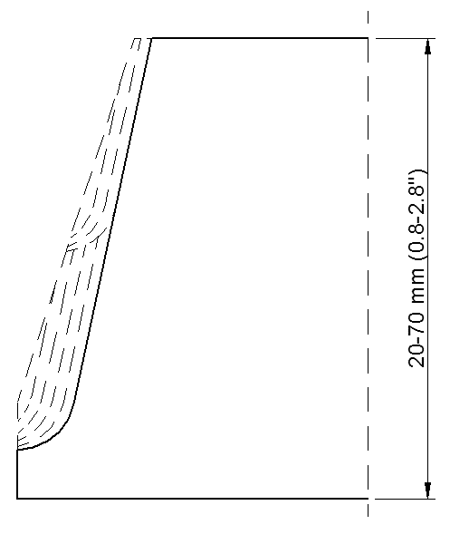
Stage 2
Stage 1
Pass 1
Pass 2
- Sample method of J-bevelling of 20-70 mm plates

ACCESSORIES

Support for bevelling 36–70 mm plates at 0° to 60°
Part number:
WSP-0518-04-00-00-0

Support for bevelling 36–70 mm plates at 0° to –60°
Part number:
WSP-0518-05-00-00-0

1.2 m (47’’) guide track
Part number:
ZSP-0518-13-00-00-0

Support for J-bevelling 20–70 mm plates
Part number:
ZST-0518-07-00-00-0
(includes: milling unit support for J-bevelling WSP-0518-07-01-00-0, chip guard OSL-0518-07-02-00-0, fixing screw SRB-000284, and retaining ring PRS-000006 for the milling head)

Part name | Part number
J-bevelling R6 milling head (without cutting inserts, 6 required) | GLW-000014
Cutting insert for J-bevelling R6 milling head | PLY-000422
J-bevelling R8 milling head (without cutting inserts, 5 required) | GLW-000015
Cutting insert for J-bevelling R8 milling head | PLY-000424

Clamp for 36–70 mm plates
Part number:
ZCS-0152-99-01-00-0
(2 required)

Track clamp for 36–70 mm plates
Part number:
UST-0152-15-01-00-1
(3 required)

Clad removal attachment
Allows removing clad whose shear strength R_{m} is up to 700 MPa (100,000 psi).
Part number:
ZST-0518-09-00-00-0
(includes: milling unit support for clad removal WSP-0518-10-00-00-0, and three track clamps of clad removal attachment for up to 35 mm plate
UST-0518-11-00-00-0)

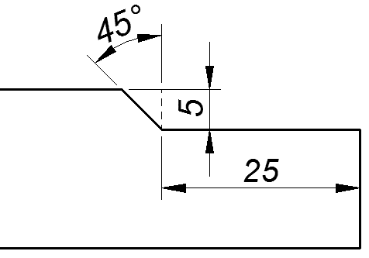
 | Maximum milling depth | 5 mm (0.2’’)
 | Maximum milling width | 25 mm (1’’)
 | Support weight | 4.5 kg (10 lbs)
 | Track clamp weight | 3.2 kg (7 lbs)

Position the carriage on the plate in the standard manner but using the track clamps of the attachment. Then, position the support on the screws, placing the washers in the order shown in Fig. 12, and tighten the nuts using the 13 mm flat wrench. Set the depth adjusting lever in the position shown in the figure and vertically insert the milling unit into the support. Set the chip container on the support.
- Installing the support
Use the depth adjusting lever and the milling unit shift knob to set a proper milling depth and width. Lock this position using lock levers. Operate by travelling the carriage from left to right.
Depth adjusting lever
Milling unit shift knob
Milling unit shift lock lever
Depth lock lever

- Adjusting the milling depth and width

Clamp of clad removal attachment for 36–80 mm and 81–127 mm plates
Part number:
ZCS-0518-08-02-00-0
(2 required)
Part number:
ZCS-0518-08-02-00-1
(2 required)
  - Track clamp of clad removal attachment for 36–80 mm and 81–127 mm plates
Part number:
UST-0518-11-00-00-2
(3 required)
Part number:
UST-0518-11-00-00-1
(3 required)

WIRING DIAGRAM
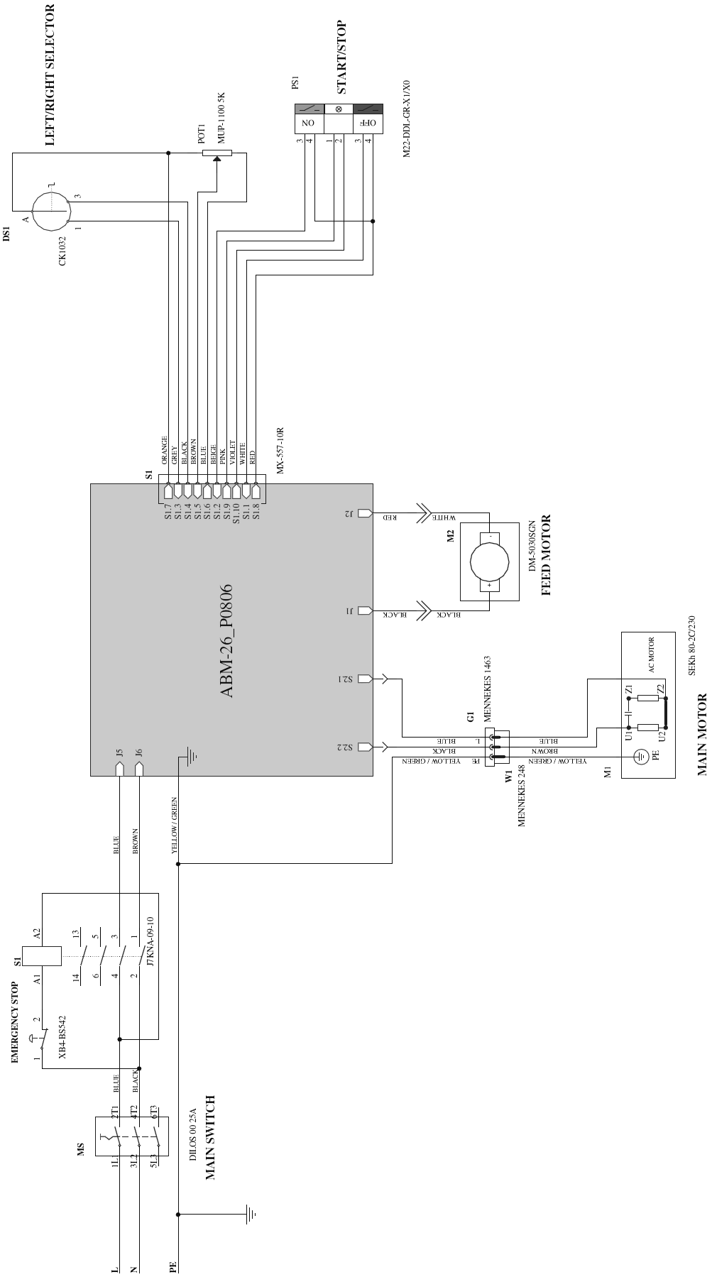

SPARE AND WEARING PARTS
Name | Number
Milling head (includes fixing screws, screwdriver, and grease; 7 inserts required) | GLW-000013
Cutting insert (sold 10 per box) | PLY-000282
Fixing screw for inserts | SRB-000311
T15P torx screwdriver for fixing screws | WKT-000005
Grease for screws (5 g, 0.17 oz) | SMR-000005

DECLARATION OF CONFORMITY

Declaration of Conformity

We

PROMOTECH sp. z o.o.
ul. Elewatorska 23/1
15-620 Bialystok
Poland

declare with full responsibility that:

ABM-28 Auto Feed Bevelling Machine for Plate Edges

is manufactured in accordance with the following standard:
- EN 60204-1
and satisfies safety regulations of the guidelines: 2006/95/EC, 2006/42/EC.

Person authorized to compile the technical file:
Marek Siergiej, ul. Elewatorska 23/1, 15-620 Białystok
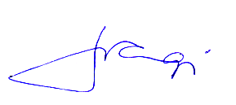
Bialystok, 16 November 2012 ___________________________
Marek Siergiej
CEO

QUALITY CERTIFICATE

Machine control card
ABM-28 Auto Feed Bevelling Machine for Plate Edges

Serial number ................................................................................

Electric test
Type of test | Result | Name of tester
Test with sinusoidal voltage  (voltage 1000 V, frequency 50 Hz) |  | ...................................  Date
Resistance of the protective circuit | ............ Ω | ...................................  Signature

Quality control .................................................

Adjustments, inspections
Quality control .................................................

WARRANTY CARD

WARRANTY CARD No.............

........................................................................... in the name of Manufacturer warrants the ABM-28 Auto Feed Bevelling Machine for Plate Edges to be free of defects in material and workmanship under normal use for a period of 12 months from the date of sale.
This warranty does not cover cutting inserts, as well as damage or wear that arise from misuse, accident, tempering, or any other causes not related to defects in workmanship or material.

Date of production

Serial number

Date of sale

Signature of seller

1.10 / 12 January 2017

WE RESERVE THE RIGHT TO MAKE CHANGES IN THIS MANUAL WITHOUT NOTICE

